DB-C4-S3-THEORY VIEW

This exercise is based on given ONLINE database:

<https://www.w3schools.com/sql/trysql.asp?filename=trysql_select_where>

* Test your queries on the online editor
* Copy / paste your answer for each question on this document

**Q1:** Write a query to create a view for all customers who are coming from France.

CREATE VIEW franceName AS SELECT CustomerName FROM Customers WHERE Country=”France”;

**Q2:** Write a query to create a view of order quantity more than 50.

CREATE VIEW Order AS SELECT Quantity FROM OrderDetail WHERE quantity>50;

**Q3**: Write a query to create a view of products with a price between $10 and $30.

CREATE VIEW Ages AS SELECT age FROM students WHERE age BETWEEN 17 AND 30;

**Q4**: Write a query to create a view of suppliers coming from Japan and only from Tokyo city.

CREATE VIEW Customer AS SELECT First_Name, Last_Name, Country FROM customers WHERE Country="China";

**Q5:** Write a query to create a view to display product name in each category without any duplicate.

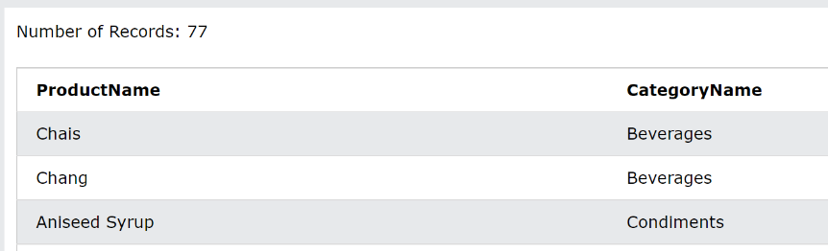

**Q6:** Write a query to create a view to display all customers and employees as seller

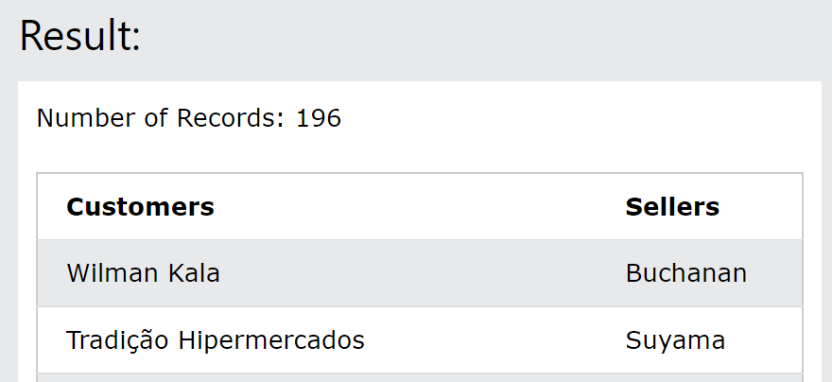

Q7: Write a query to create a view for those salesmen belongs to the city New York.

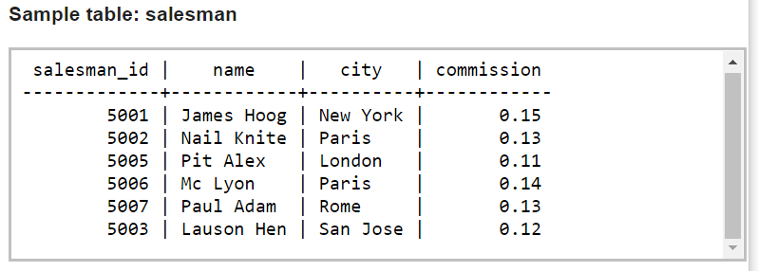

**Q8:** Write a query to find the salesmen of the city New York who achieved the commission more than 13% with the view you just created in Q7.